The UDP Band Map
Aki Yoshida JA1NLX

1. 0 GENERAL

Logger32 has a function to receive and display decoded callsigns with some additional informations on the UDP BandMap. This data is distributed via UDP (User Datagram Protocol) appromixmately every 15 seconds (FT8 Mode) or 60 seconds (JT65, JT9 Mode etc) by WSJT-X/JTDX program.
When QSO is logged in WSJT-X/JTDX then Logger32 log this QSO via UDP.

Note 1: When QSO is logged in JTDX then Logger32 will log this QSO via UDP.
Note 2: The UDP BandMap and JTAlert program work at same time.
Note 3: If using JTDX, use either the TCP Server method OR this UDP server method – NOT both.

2. WSJT-X/JTDX SETTINGS

2.1 Settings in WSJT-X program

Look for UDP Server group. You should leave the default value like this.

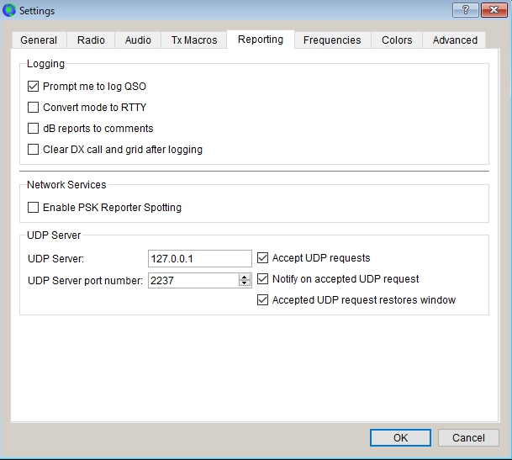

UBM_1

2.2 Settings in JTDX program

Look for UDP Server group. You should leave the default value like this.

If you do not use External logbook connection then uncheck "Enable data transfer to external log"

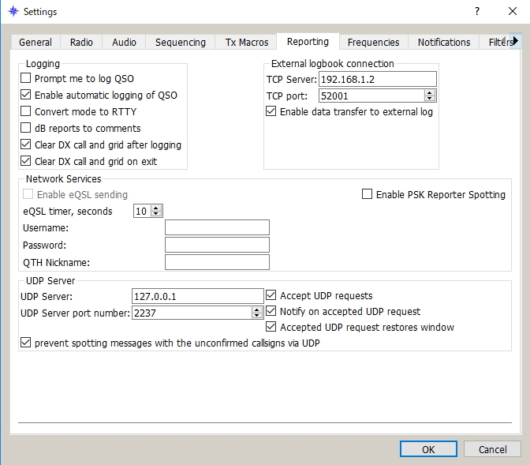

UBM_2

3.0. LOGGER32 SETTINGS
The callsign highlight colors and DXCC award tracking informations displayed in UDP BandMap depend on the settings in "DX Spot highlight color" and "Setup phone/digital modes"

Settings for me to operate FT8, JT9 and JT65 below.

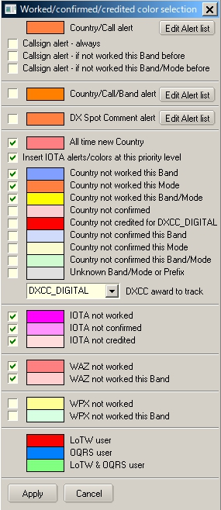

UBM_3

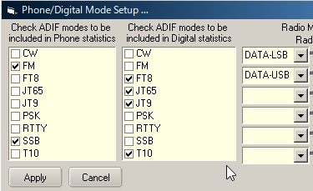

UBM_4

With this settings Worked/confirmed Window looks like below.

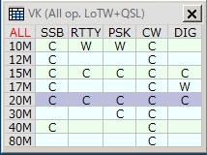

MBM_4A UBM_4A

4. OPERATION (1)

  - Run WSJT-X or JTDX. Do not run JTAlert at same time.
  - Run Logger32
  - Right click on "UDP" in the lower status bar. Click "Open UDP BandMap"

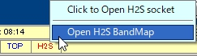

UBM_5

When WSJT-X or JTDX decode callsigns these callsigns are displayed in the UDP BandMap.

WSJT-X or JTDX, Band and Mode are displayed in title bar. Band and Mode are derived from WSJT-X or JTDX.

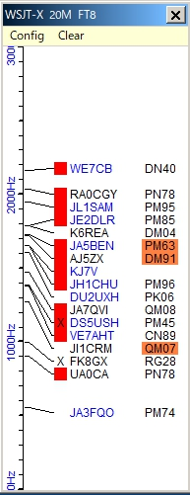

UBM_6

  - Click "X" to close UDP BandMap.

5.0 MENU

5.1 Config

There are a lots of options. You may choose whatever you prefer now.

If you want to see highlight colors and tooltips informations based on every mode then un-check "Highlight callsigns as "DIG" mode" This option works for displaying "QSOd B4" mark as well.

If you want to use direct logging then check "Allow QSO automatic logging" If you want to see Gridsquare then check "Show Gridsquares"

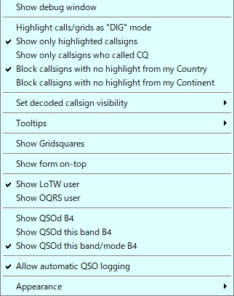

new UBM_7

Sub menu for "Set decoded callsign visibility"

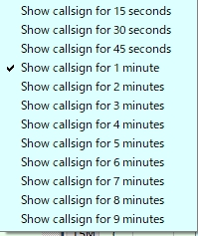

UBM_8

Sub menu for "Tooltips"

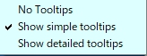

UBM_9

Sub menu for "Appearance"

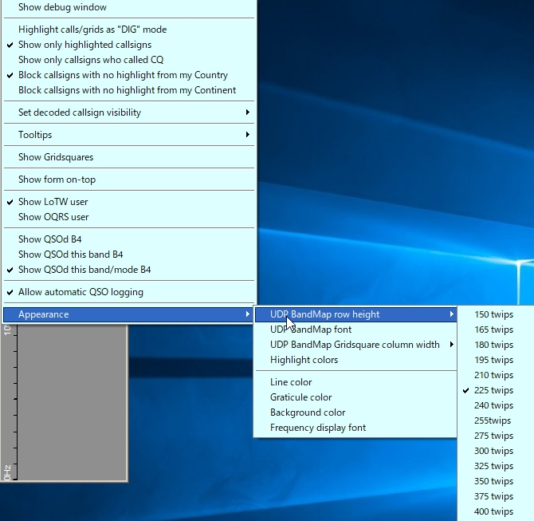

HBM_10 new UBM_10

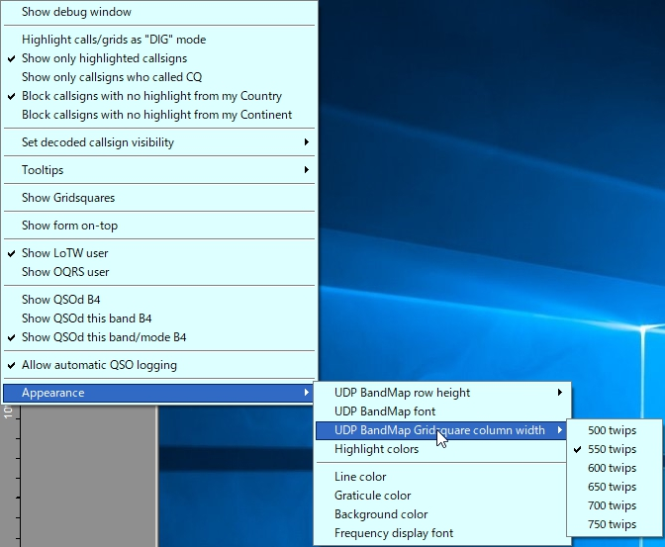

HBM_10A new UBM_10A

Click "Highlight colors" to configure Gridsquare highlight colors and UDP BandMap text color. If you prefer to see bold text for CQing callsign then check "Show bold text when station CQing".

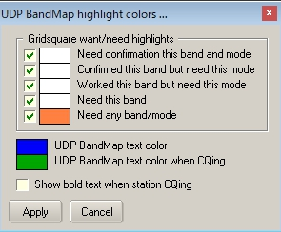

HBM-11 UBM_11

5.2. Clear

This clears UDP BandMap.

6. OPERATION (2)

If you move mouse over callsihn then tooltips appears.

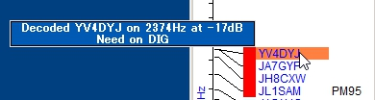

UBM_12

If you left-click any callsign then this callsign is transferred in Logbook Entry Window.

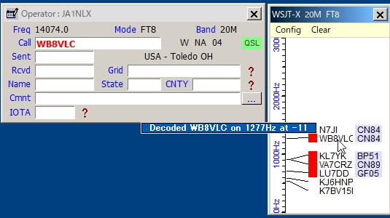

UBM_13

If you right-click any callsign then history of this callsign is displayed. (max 15 messages)

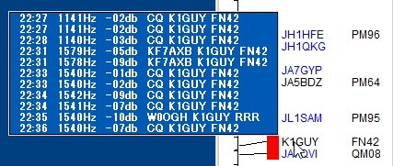

UBM_14

If you confugure various options properly then you see LoTW/OQRS user, QSO B4, highlighted callsign and Gridsquare.

When QSO is logged in WSJT-X/JTDX then Logger32 log this QSO via UDP if "Allow QSO automatic logging" is checked.

70. TIPS

If you have "Show only callsigns calling CQ" and "Show only highlighted callsigns" checked then the only station that are highlighted and calling CQ will show.
The BLOCK COUNTRY and BLOCK CONTINENT options look for a Country/Continent match with the Logger32 Current Operator. If you have the Logger32 operator set to "At the Beach" or "Club Station" or something other than the callsign of where you are operation, the results will be unpredictable.

Try to change settings of "DX Spot highlight colors" in DX Spot Window and settings of "Setup phone/digital modes" in Tools menu. It affects the way to display highlight colors and tooltips in UDP BandMap.

Debug window is very useful to check problem. Click "Show debug window" in Config menu to show debug window.

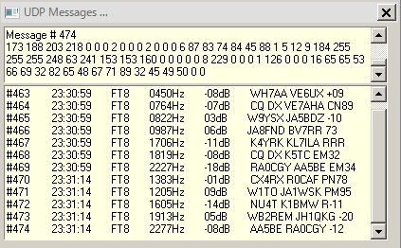

UBM_15

